**Creative Process – Getting to the Game – Sound Pirates**

The project brief was to create a novel application which incorporated modern real-time techniques of programming in C++ within hardware constraints and under a budget of £50.

The hardware was to be a raspberry pi or a laptop running on Linux. User inputs and responses were to be captured and feedback given in real-time within a loop containing no blocking processes such as wait or delay. The program would use threads and interrupts to maintain parallel programs with low latency reactions.

To come up with the teams’ pitch idea the double diamond method was employed. The four stages of Discover, Define, Develop, and Deliver used to explore options and then refine them into a solid idea to work towards.

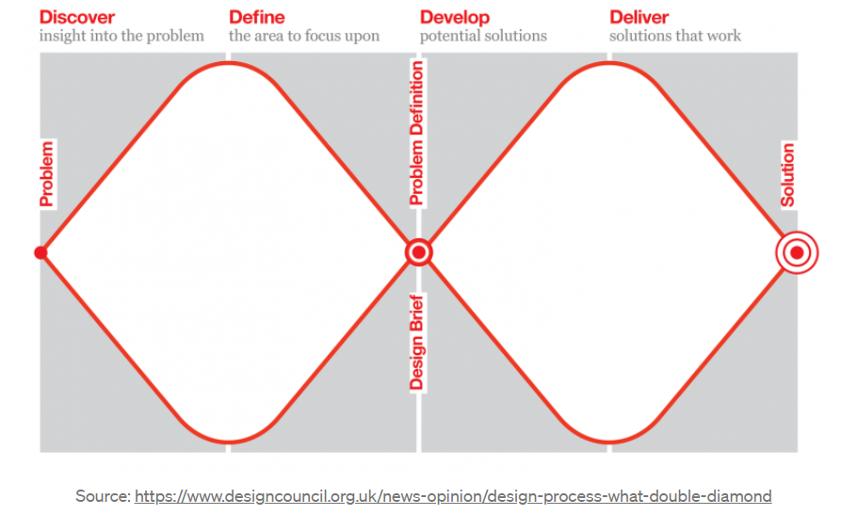

This document is compiled from notes on conversations, meeting minutes and discussions, it shows the ideas and reasoning this process involved.

**Stage 1 Discover (expanding possibilities)–**

The team invites any and all ideas which could be developed for the project;

Air Quality sensor mounted in light fittings

Remote control car using EMG to control for rehab

Impact protection system for toddlers

Hug Jacket for long distance emotional support

Movement tracking for boxing/fencing with 3D grid on floor and body

Small scale shunt for continuous small samples of blood for monitoring instead of drawing large sample of blood daily

Mouth/tongue based games controller for quadriplegics/paralysed

Hearing aids with focussing ability

Balance assist equipment [Gollee’s research]

Spellsingers- game where musical phrases used to generate magical effects

Machine learning game where generated landscape is given and players choose limbs/body parts to traverse it

An entirely sound based game, no graphics

Vs Spells- movement of a wand tracked to perform spells

Rube Goldberg machine maker, build a track and watch a ball fall through it

Anthropomorphism of the elements of the periodic table, each with simplified attributes given using object-oriented programming. To teach kids pokemon style about chemistry and how the periodic table works and how object based programming works with inheritance of properties etc.

Entropy vs growth, plant a garden and grow it while challenges hit.

Opposite Action! Start off as a massive, powerful, loads of armour, loads of weapons thing, every level something breaks and fails or falls off, enemy numbers are finite, but you’ll need to figure out how to kill most efficiently each stage of the way until it just you as a lvl1 dude with nothing but reputation and bare hands.

General interest

-Games

-Rehabilitation [example Parkinsons spoon, example sonar echolocation for the blind]

-Haptics

-Sports Equipment

Now the team has a pool of potential projects and looks critically at the ideas, cutting those which do not meet the brief, have issues, or are simply less interesting. General interest in certain areas has also been identified, so those areas can be explored.

**Stage 2 Define (reducing options)–**

The team takes the results of stage 1 and removes unsuitable ideas, pushing towards a final idea which is realistic and fits the brief.

~~Air Quality sensor mounted in light fittings~~

Unlikely to need real-time, already exists

Remote control car using EMG to control for rehab

Possibility – Shortlisted for refinement

~~Impact protection system for toddlers~~

Health & Safety nightmare

~~Hug Jacket for long distance emotional support~~

Lack of tailoring skills within team

Movement tracking for boxing/fencing with 3D grid on floor and body

Possibility – Shortlisted for refinement

~~Small scale shunt for continuous small samples of blood for monitoring instead of drawing large sample of blood daily~~

Not suitable for brief

~~Mouth/tongue based games controller for quadriplegics/paralysed~~

Extreme environment, unlikely to be functional within timeframe

~~Hearing aids with focussing ability~~

Unlikely to be functional within timeframe

~~Balance assist equipment [Gollee’s research]~~

Unlikely to be functional within timeframe

Spellsingers- game where musical phrases used to generate magical effects

Possibility – Shortlisted for refinement

~~Machine learning game where generated landscape is given and players choose limbs/body parts to traverse it~~

No real-time application, does not fit brief

An entirely sound based game, no graphics

Possibility – Shortlisted for refinement

Vs Spells- movement of a wand tracked to perform spells

Possibility – Shortlisted for refinement

~~Rube Goldberg machine maker, build a track and watch a ball fall through it~~

No real-time application, does not fit brief

~~Anthropomorphism of the elements of the periodic table, each with simplified attributes given using object-oriented programming. To teach kids pokemon style about chemistry and how the periodic table works and how object based programming works with inheritance of properties etc.~~

Unlikely to be functional within timeframe, graphically intensive.

~~Entropy vs growth, plant a garden and grow it while challenges hit.~~

Unlikely to be functional within timeframe, graphically intensive.

~~Opposite Action! Start off as a massive, powerful, loads of armour, loads of weapons thing, every level something breaks and fails or falls off, enemy numbers are finite, but you’ll need to figure out how to kill most efficiently each stage of the way until it just you as a lvl1 dude with nothing but reputation and bare hands.~~

Unlikely to be functional within timeframe, graphically intensive.

General interest

-Haptics

-Sports Equipment

-Games

-Rehabilitation [example Parkinsons spoon, example sonar echolocation for the blind]

********************************************************

At this point the team has an identified particular interest in games with purpose, exercise, and rehabilitation.

The distilled ideas amounted to these concepts;

EMG sensors measuring exercise intensity gamified.

Identification of sounds for a game.

Movement tracking gamified.

**Stage 3 Develop (exploring the specific ideas)–**

The team develops the shortlisted ideas, exploring the possibilities they represent before making a decision on which to pitch. It was it this point the team polled friends and family for their reactions to potential projects.

**EMG Sensors based projects;**

Sensors measure the intensity of work done by muscles. Use these signals to measure exercise intensity or to control graphical movement within a game.

A continuous runner game ‘on rails’, movements required at set points. Competitive games akin to fairground tests of strength.

This application could be used in physical rehabilitation and for general health.

Issues; access to sensors for users, space requirements, problems with artifacts inherent in biosensor analysis, health and safety liabilities.

These concepts gained favourable responses from informal polling, though the issues of designing and building hardware, getting equipment to users, and the liability issues meant this direction was deemed unsuitable.

**Movement tracking gamified;**

Vs Spell – a wand has its movement tracked as the players perform certain motions to cast spells. Multiplayer game.

A battle of magic where players can cast offensive spells at each other in game, or try and dispel the opponents magic.

This application could be used for fine motor skills rehab or pure entertainment.

Issues; this concept would require hardware design and creation and may need network capabilities to function.

This application also did well with polling but to be a genuinely fun and useful game, there would be a degree of complexity required that may not be possible in the timeframe given. Couch-based multiplayer games are less attractive during COVID.

**Identification of sound based projects;**

Spellsingers – musical phrases used to generate ‘spells’ within game.

This concept was refined, whole musical phrases were likely to be too complex to identify so moved to;

Note identification – certain sound frequencies identified to train musicians to hear notes by ear and reproduce them. As a ‘Simon Says’ game or to control sprites within a game.

Polling suggested this could be useful for musicians in training and generated some good interest. The concept was further developed to install more motive and impetus to the player of the game by introducing a story. The player would be involved in a spaceship chase, the correct playing of the note would mean gaining on the quarry and an incorrect note loss of ground.

**Stage 4 Deliver (decide on method and firm first design concept)-**

The concept which was decided to move forward with is the sound identification game. Refined into a note identification process. This basic concept would be achievable and had multiple pivot possibilities past the simple game available to develop.

A game loop would be designed which offered an example note and listened for the same note to be provided by the player. If the program identifies that the correct note has been played then a positive action is taken, if it is incorrect then a negative.

The Sound Pirates game was pitched as the project, the basic spaceship chase chosen as the basis for the game the team would develop. The game would require a raspberry pi and a soundcard to work, with audio in and outputs, but these are common and inexpensive. The primary target market would be musicians and singers in training, with a secondary market of general gamers.

The game was developed to recognise a select range of notes at first, but it could be altered to train not just the traditional notes but microtonal notes and non-traditional scales. Other game modes could also be available as stretch targets.

Lore was developed for the game and design started on the graphics, both 3D and 2D. Examples of these alternates are also in the git for the game.